**LEETCODE SOLUTION**

1. Roman to Integer:

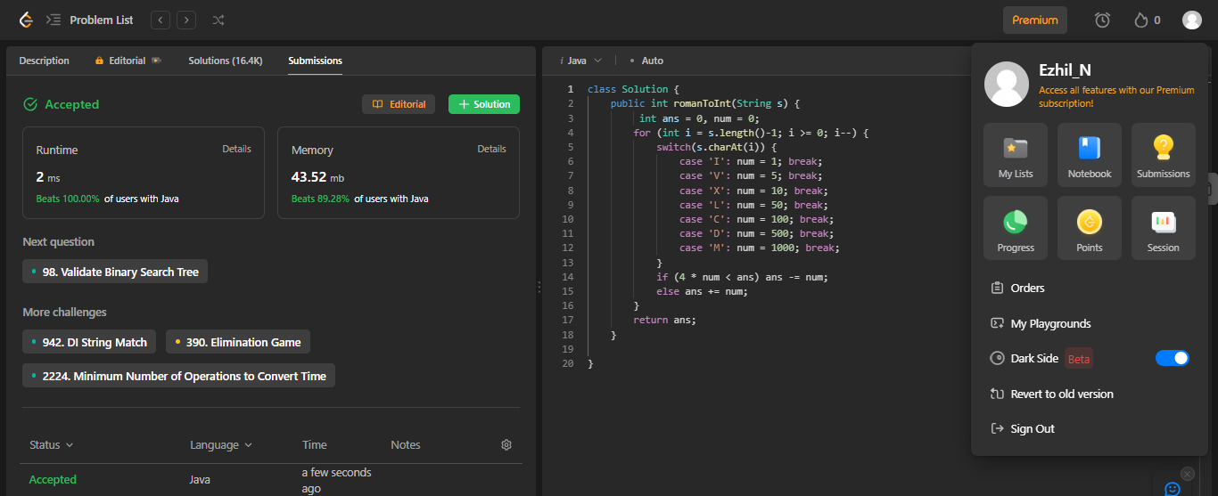

1. Longest Common Prefix:

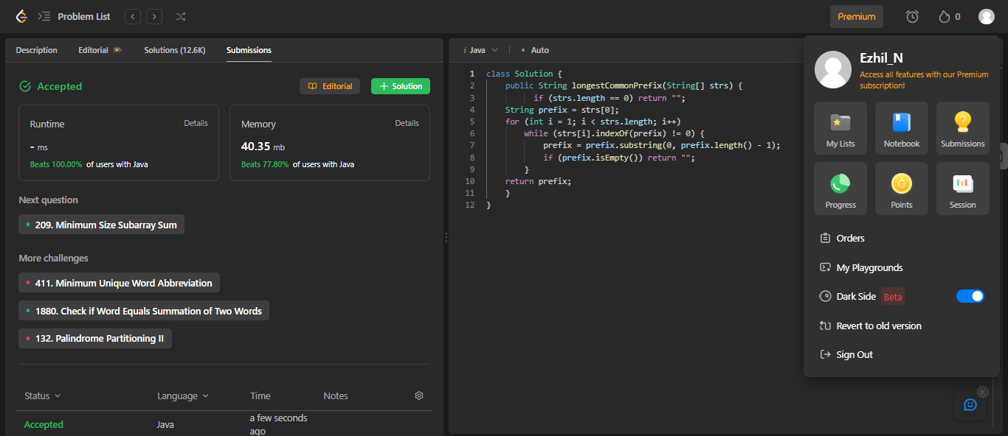

1. **Valid Palindrome:**

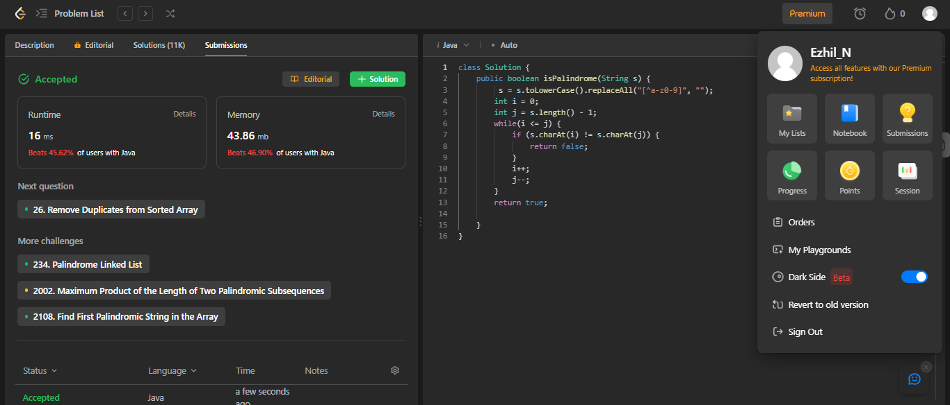

**4.Valid Anagram:**

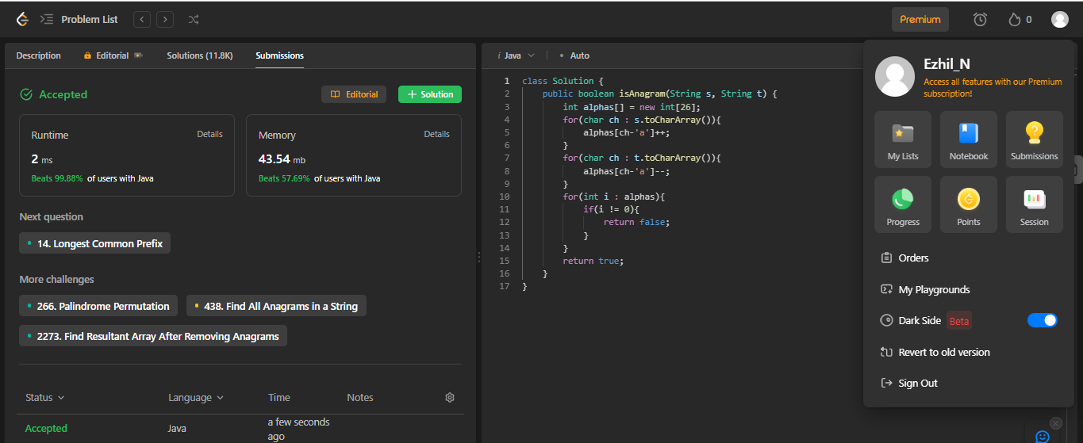

5.Reverse Words in a String:

